2020 Registration Form

Club Mobile: 07797 908280 Email minimesholidayclub@gmail.com
‘Mini Me’s Holiday Club is a registered holiday playcare setting, for school aged children, under the Day Care of Children (Jersey) Law and we are compliant with regulations set to us, by Jersey Child Care Registration’ Our registration number is AC.13. Please also note that Mini Me’s Activities, follow all guidelines of the Data Protection Jersey Law 2005, therefore all confidential information, will be handled with the upmost discretion.

Form & | Payment | Details
1. Child’s | Details | Parent |  | / | Guardian | Details

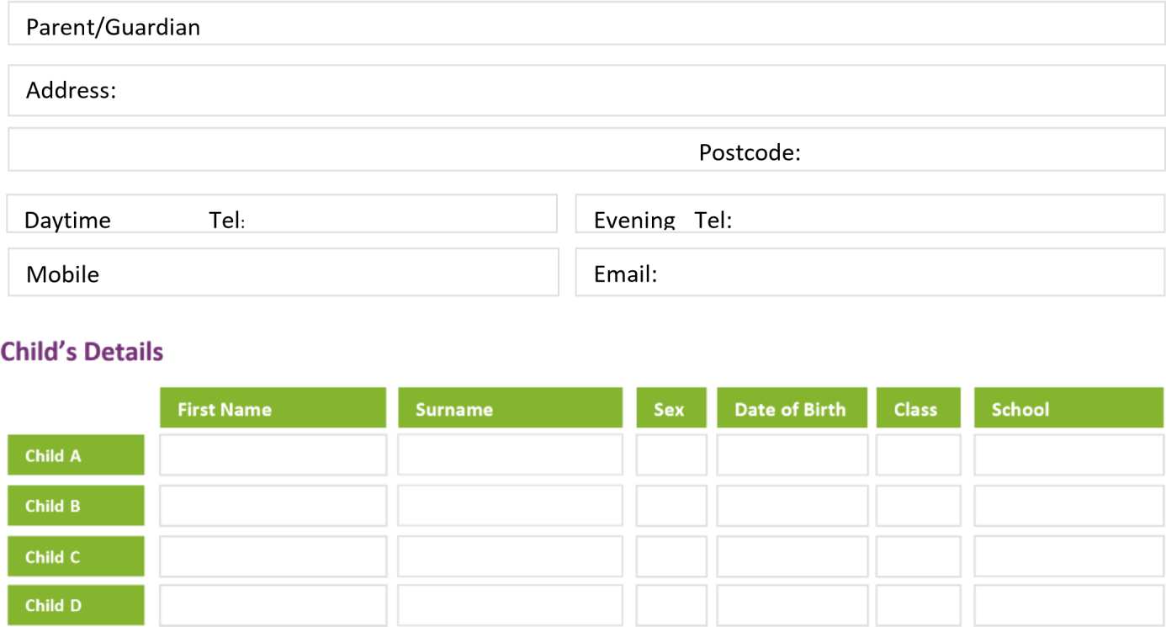

Please indicate a start date, which session you require, and how many weeks of the year you will need our holiday club. There are approx. 12 school holiday weeks per year.
Start date:…………………………………………………………………Amount of weeks:……………………………………………………………………

Session times, are set to the following:
Half days 8am – 1pm or 1pm-6pm £25.00 per day
School Hours 8am – 3.30pm £37.50 per day. Weekly discounted rate £168.75
- Long days 8am – 6pm £50 per day. Weekly discounted rate £225.00
There is a 10% discount for a second sibling

Payment Details

Parents/Guardian’s Name:……………………………………………………………………………………………………………………………………

Childs Name:…………………………………………………………………………………………………….. Childs Age………………………………..

I wish to pay for my child/children’s my holiday club fees as follows (please tick):

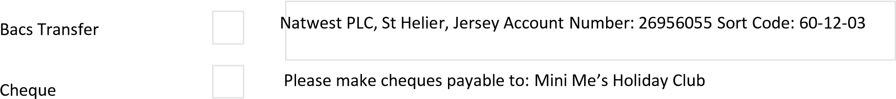

3. Medical Form

Please complete this form and sign where indicated at the foot of the page. Child Medical Details
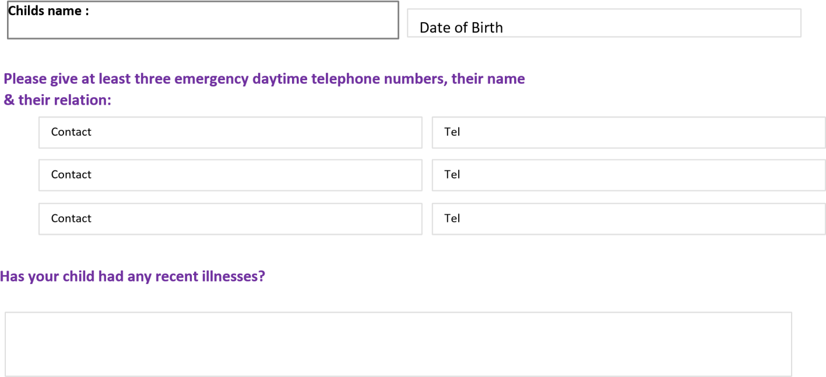

Does your child have any allergies? Food ie. egg or nuts? Is your child allergic to bee, wasp or insect stings? YES or NO If yes, please describe in detail, the symptoms of the allergy.

Does your child have to take regular medication? If yes, please give details.

For the purpose of understanding and awareness, we will need to know if your child is or has been involved with any outside agencies. For example, Childrens Services, Child and Adult Mental Health services (CAMHS) or Family Liaison etc.

Please state the name, address and telephone number of your child’s doctor.

Please provide any additional information you feel we should know concerning your child.

Please sign and date below to confirm your consent for Mini Me’s (first aid trained staff) to administer first aid to your child if required.
“Please note that Mini ME’s staff, will always follow our Health & Safety Policies, and at all times will have the children’s best interests in mind. However, medicines will only be administered under the written request of a GP, with a prescription and the container sealed, and only opened in front of us. You may also be asked to discuss and complete a written action plan, with the manager of our setting”
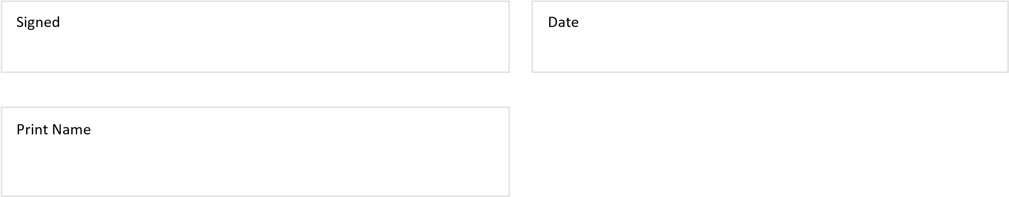

We at Mini Mes, hold data about your child and therefore are a data controller and are subject to follow, the General Data Protection Regulation GDPR. Which came into force, in May 2018. Please be aware that we are holding the data you have provided on this form, however this data will not be shared. Our full Data Protection Policy can be found on our website or if requested can be provided to you.

4. Terms & Conditions

(A full account of our Terms & Conditions can be found on the reception desk at club. Please ask a member of staff to point you in the right direction)

Booking & Payment Terms
- We cannot secure a booking without a booking form and payment.
- Payment is due 14 days before each holiday.
- No refunds will be given for absence due to illness
- No refunds will be given for a date or time change, made after the 14days.
- We do reserve the right to cancel a booking, if we have not received prior payment.

Health & Safety
- All areas and outings are safety checked and risk assessed at the start of each day. All children will be familiarized with fire exits, meeting points and emergency procedures.
- A detailed register will be completed for each child. This ensures that all staff are fully aware of any special health or educational needs.
- A qualified first aider and a fully stocked first aid box will be available at all times.
- All our equipment is regularly checked.

Child Protection Procedures
- All of our staff have the relevant qualifications and been given police clearance to work with children.
- Each day all parents/guardians will be required to sign our sign in book, t to ensure that children are only collected by themselves or a nominated adult
- No other adults apart from, staff and checked persons will be allowed in club.
- We reserve the right not to accept any child who, in our opinion, is not well enough to take part in the club.

Behaviour Policies & Equal Opportunities
- All children will are aware from their first day, our ‘club rules’ as we set all our rules together as a team. Each child is listened to and take it in turns to sign our club rules, to show us they understand. It is then our contact to work together, to keep a safe environment for them, their friends and staff.
- It is not our policy to exclude disruptive children from the club. Challenging behaviour will be dealt with patiently through distraction techniques and one to one “buddying”. They may be asked to have a few mins thinking/chill out time.
- Where continued disruptive behaviour prevents others from enjoying themselves or poses a safety issue, a parent/guardian may be asked to collect them.
- None of our staff use any form of physical or mental punishment.

Photos & Social Media – each holiday we like to take photos as memories. These photos may be displayed within the setting, on our website, on facebook page or even the JEP. No names or identities are ever given without your consent.

Please circle one:

I give my permission for Mini Me’s to take photos. I do not give my permission for Mini Me’s to take photo.

I have completed, signed and enclosed ALL three sections of the application form:
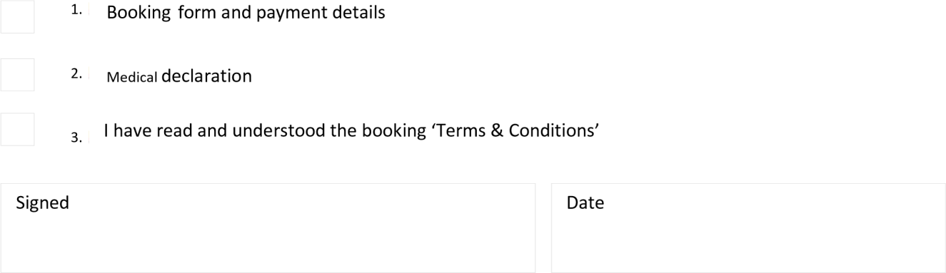

Please return ALL completed forms to:

Mrs Marguerite Gilley - Mini Me’s Activities Holiday Club,
Moncrieffe
La Grande Route De St Ouen
St Ouen
Jersey
JE3 2HY

By returning this form, you acknowledge, fully understand and accept the ‘Terms & Conditions’ of Mini Me’s Holiday Club.

Thank you, from Marguerite & All The Team at Mini Me’s ;o)

